Style Guidelines for Final Year Project Reports (Research and Development)

Title of the Project
Final Year Project Proposal
Session Fall 2026

BS in CS/SE/AI/CY



Department of CS/AI/SE/CY
Fast School of Computing
Fast National University, Karachi Campus
1st September 2026

Project Registration
Project ID (for office use)
Type of project |  |  | [ ] Traditional [ ] Industrial [ ] Continuing
Nature of project |  |  | [ ] Development [ ] Research & Development [ ] Research
Sustainable Development Goals(SDGs) |  |  | [ ] Good Health and Well-Being [ ] Quality Education  [ ] Industry, Innovation, and Infrastructure [ ] Gender Equality  [ ] Decent Work and Economic Growth [ ] Climate Action
Area of specialization |  |  | [ ] Artificial Intelligence (AI) [ ] Data Science and Analytics  [ ] Internet of Things (IoT) [ ] Blockchain  [ ] Mobile App Development [ ] Web Development [ ] Cybersecurity  [ ] Game Development [ ] Natural Language Processing (NLP)  [ ] Other
Project Group Members
Sr.# | Reg. # | Student Name |  | CGPA | Email ID | Phone # | Signature
(i) | Group Leader
(ii)
(iii)
Declaration: FYP group members have cleared all prerequisite courses For FYP-I as per their degree requirements.

- Project Abstract (mandatory)
Modern video surveillance networks are widely deployed across urban environments, yet they function predominantly as passive recording infrastructure requiring continuous human monitoring. Security operators suffer from rapid cognitive fatigue, missing over 90% of real-time security threats within just 20 minutes of active observation. Furthermore, existing automated threat detection systems address only static weapon identification, leaving a critical research gap in recognizing dynamic violent crimes where weapons are absent.
To bridge this gap, this project presents SENTINEL, an end-to-end AI-powered real-time surveillance framework that unifies weapon detection and temporal human action recognition into a single automated pipeline. SENTINEL executes two concurrent inference tasks on live CCTV feeds: frame-level detection of guns and knives utilizing a fine-tuned YOLOv8 object detector, alongside pose-based temporal crime classification using YOLOv8-Pose skeletal key point extraction fed into a lightweight LSTM classifier to identify critical crime behaviours including fighting, robbery and shooting.
To mitigate false alarms caused by momentary visual noise (e.g., a smartphone briefly resembling a firearm), SENTINEL employs a sliding-window temporal buffer that requires threat detections to persist across multiple consecutive frames before triggering an alert.
This project expects to achieve over 25 frames per second with sub-second alert latency, transforming passive surveillance into an automated threat detection system while maintaining high precision through temporal false-alarm suppression.

Introduction (mandatory)
The research domain of this project lies at the intersection of Computer Vision, Deep Learning-Based Object Detection, and Spatio-Temporal Human Action Recognition applied to intelligent video surveillance systems.
Public safety and urban security are among the most critical challenges facing modern societies. According to the World Health Organization, interpersonal violence accounts for over 475,000 deaths annually, with countless more incidents of assault, robbery, and theft going undetected or detected too late for intervention. Closed-circuit television (CCTV) surveillance networks have been deployed worldwide to deter and document criminal activity, yet the overwhelming volume of video data generated by these networks far exceeds the capacity of human monitoring personnel.
Currently, the vast majority of CCTV infrastructure functions as a passive post-incident forensic tool. Security footage is typically reviewed only after a crime has been reported, rendering the surveillance system reactive rather than preventive. This means that crimes committed without a visible weapon (physical assault, snatching) go entirely undetected by existing solutions.
Recent advances in real-time object detection (YOLO family), human pose estimation (skeletal key point extraction), and lightweight recurrent neural networks (LSTMs) have made it computationally feasible to perform multi-modal video understanding at interactive frame rates on consumer-grade GPU hardware. These technological enablers create an unprecedented opportunity to transform passive surveillance infrastructure into intelligent, proactive threat detection platforms capable of autonomously identifying both weapon-based and behavioral crime anomalies in real time.

Problem Statement
Existing real-time video surveillance systems suffer from three fundamental and interconnected deficiencies:
Human Operator Cognitive Overload: Studies in surveillance psychology demonstrate that human CCTV operators experience significant performance degradation after 20 minutes of continuous monitoring, resulting in a missed-event rate exceeding 90% during extended shifts. This renders human-dependent monitoring operationally unreliable for time-critical threat detection.
Static Object Detection Blindness: Current AI-based surveillance solutions detect the presence of weapons in isolated frames. However, they are architecturally incapable of recognizing dynamic criminal behaviours physical assault (fighting), street robbery, or active shooting scenarios — where behavioral context across time is required for accurate classification. This creates a critical detection gap for the majority of urban violent crimes.
Excessive False Alarm Rates: Single-frame detection models frequently misclassify benign objects (smartphones, wallets, umbrellas) as threats due to visual similarity, generating alarm fatigue that causes operators to ignore genuine alerts. No temporal validation mechanism exists to distinguish momentary visual noise from persistent, confirmed threats.
Research Gap: There exists no unified, real-time surveillance system that simultaneously performs weapon detection, temporal behavioral crime classification, and algorithmically-validated false-alarm suppression within a single deployable pipeline operating at interactive frame rates on accessible hardware.

Motivation (mandatory)
The motivation behind this project is to develop a practical, deployable, real-time intelligent surveillance solution that transforms passive CCTV infrastructure into an active crime detection and alerting platform. Specifically, the project aims to:
Eliminate Dependence on Human Operators: Automate continuous 24/7 threat monitoring to remove the cognitive bottleneck of human fatigue-induced performance degradation.
Bridge the Weapon-Only Detection Gap: Extend beyond static weapon identification to recognize behavioural crime patterns (fighting, robbery, shooting) that constitute the majority of urban security incidents.
Suppress False Alarm Algorithmically: Implement a temporal consistency buffer that validates detections across consecutive frames, dramatically reducing operator alarm fatigue.
Provide Actionable Situational Awareness: Deliver instant, multi-channel alerts (dashboard siren, email with snapshot, database audit logging) to security personnel for rapid incident response.
Ensure Accessibility: Design the system to operate at real-time speeds on consumer-grade hardware, making intelligent surveillance accessible to institutions beyond well-funded government agencies.

Aims and Objectives
To design, implement, and evaluate an end-to-end intelligent real-time video surveillance system that unifies weapon detection with temporal behavioral crime classification and automated alert dispatch.
Objectives:
- Fine-tune a YOLOv8 object detection model on curated weapon datasets to accurately detect and localize guns and knives in live video frames.
- Implement YOLOv8-Pose human skeletal key point extraction to capture 17 body joint coordinates per detected person per frame.
- Design and train a lightweight LSTM-based temporal action classifier that processes sequential key point trajectories to classify 3 crime categories: Fighting, Robbery, and Shooting + Normal (4-class output including Normal).
- Develop a sliding-window temporal consistency buffer to suppress false alarms with zero additional computational overhead.
- Build an asynchronous backend with WebSocket-based live video streaming and incident event broadcasting
- Develop a real-time monitoring dashboard with Canvas bounding-box overlay rendering at 30 FPS, audible siren alerts, and incident history browsing.
- Implement a persistent incident audit database storing timestamped snapshots, threat classification, confidence scores for every confirmed event.
- Integrate automated email alerting that dispatches incident notifications with threat-type classification and snapshot image attachment.
- Evaluate system performance on standard benchmarks, reporting Accuracy, Precision, Recall.

Scope of the Project
In-Scope (Committed Deliverables)
- Single-stream real-time video ingestion.
- weapon detection: Guns and Knives (2 classes).
- 3-class behavioral anomaly classification + Normal: Fighting, Robbery, Shooting.
- Pure temporal consistency buffer for false-alarm suppression.
- Real-time web-based operator dashboard with live video stream, canvas-rendered bounding boxes,
- audible alarm, and incident history.
- Incident database audit trail (timestamp, snapshot image, threat class, confidence score).
- Automated email alert dispatch with incident snapshot attachment.
Out-of-Scope (Explicitly Excluded)
- Multi-camera network tracking and cross-camera person re-identification.
- Real-time facial recognition and suspect watchlist matching (practical CCTV limitations: low resolution, top-down angle, masked faces).
- Concealed weapon detection (physical sensor limitation — requires X-ray/millimeter-wave hardware).
- Audio-based acoustic threat detection (gunshot/screaming — different sensor modality).
- Edge hardware deployment (NVIDIA Jetson Nano / Raspberry Pi optimization).

Proposed Methodology
Step 1: Dataset Collection & Preparation
Weapon Detection: Use "Weapon Dataset for YOLOv5" from Kaggle (~4,000 images: 2,000 handguns + 2,000 knives) as the primary 2-class (Gun, Knife) training dataset. Supplement with negative-sample images from "Weapon Detection for YOLO" dataset (22,700+ images, single "Weapon" class) to reduce false positives.
Action Recognition: Source behavioral crime video clips from the official UCF-Crime dataset and RWF-2000 dataset. Supplement with temporal augmentations (speed jitter, temporal cropping).
Apply standard augmentations: horizontal flip, mosaic, brightness/contrast jitter, and random crop for robustness.
Step 2: Weapon Detection Model Training (YOLOv8)
Fine-tune YOLOv8-small on the curated 2-class (Gun, Knife) weapon dataset, primarily from "Weapon Dataset for YOLOv5" (~4,000 images), supplemented with negative-sample images from "Weapon Detection for YOLO" dataset to reduce false positives.
Step 3: Human Pose Estimation (YOLOv8-Pose)
Deploy pre-trained YOLOv8-Pose model to extract 17 skeletal joint keypoints (x, y, confidence) per detected person per frame.
No additional training required — uses pre-trained weights directly.
Limitation: Pretrained accuracy may degrade in occluded/crowded CCTV scenes (COCO training data is mostly unoccluded, close-range subjects); mitigated by using the YOLOv8m/l-pose variant for improved robustness.

Step 4: Temporal Action Classifier Training (LSTM)
Extract keypoint coordinate sequences across sliding windows of 30 consecutive frames.
Feature vector per frame: 17 joints × 3 values (x, y, confidence) = 51-dimensional input vector.
Train a 2-layer LSTM (96 → 128 hidden units, dropout 0.3, batch normalization) with Softmax output over 4 classes: {Fighting, Robbery, Shooting, Normal}.
Training: Categorical cross-entropy loss, Adam optimizer, EarlyStopping (patience=20), ReduceLROnPlateau.
Step 5: Temporal Consistency Buffer (False-Alarm Filter)
Maintain a global scene-level sliding window buffer of the last detection/classification outputs.
Implementation: Pure in-memory deque data structure — zero additional neural network inference overhead.
Step 6: Backend & API Development
Implement asynchronous video capture thread (OpenCV) feeding frames to the AI inference pipeline.
Expose RESTful API endpoints for incident retrieval, system status, and configuration.
Implement WebSocket server for real-time frame broadcast and instant alert push to connected dashboard clients.
Step 7: Frontend Dashboard
Build a single-page surveillance monitoring application.
Backend sends each processed frame along with detection coordinates as JSON metadata; frontend renders bounding boxes and keypoint skeletons client-side on HTML5 Canvas overlay at 30 FPS.
Integrate audible alarm notification, alert banner with threat classification, and incident history table with search/filter.
Step 8: Integration & End-to-End Testing
Integrate all modules into a unified pipeline: Camera → YOLOv8 → Pose → LSTM → Buffer → Alert → Dashboard.
Conduct quantitative evaluation on benchmark datasets and qualitative live webcam demonstrations.
Report: Precision, Recall, F1-Score (both weapon detection and LSTM), Real-Time FPS (overall pipeline throughput.

Functional Requirements
ID | Requirement
FR-01 | System shall ingest real-time video.
FR-02 | System shall detect and localize guns and knives with bounding boxes and confidence scores.
FR-03 | System shall extract human skeletal keypoints (17 joints) for each detected person.
FR-04 | System shall classify behavioral anomalies into 3 crime categories: Fighting, Robbery, Shooting (+ Normal).
FR-05 | System shall apply temporal consistency filtering before confirming threat alerts.
FR-06 | System shall display live video feed with real-time bounding box overlays on a web dashboard.
FR-07 | System shall trigger an audible alarm and visual alert banner upon confirmed threat detection.
FR-08 | System shall log every confirmed incident to the database with timestamp, snapshot image, threat class, and confidence.
FR-09 | System shall dispatch automated email alerts with incident image attachment upon threat confirmation.
FR-10 | System shall provide an incident history view with search and filter functionality.
Non-Functional Requirements
ID | Requirement
NFR-01 | System shall process video at ≥25 FPS (target: 30 FPS) for smooth real-time operation.
NFR-02 | Threat-to-alert latency shall not exceed 1 second from initial detection to dashboard notification.
NFR-03 | System shall operate on consumer-grade GPU hardware.
NFR-04 | Dashboard UI shall be accessible via modern web browsers.

System Architecture
The proposed system will follow a [three-tier/client-server/MVC/microservices] architecture. The major layers/components will include:
Presentation Layer – User interface
Application Layer – Business logic
Data Layer – Database and data management
The overall workflow will be
User → User Interface → Application/Backend → Database → Results
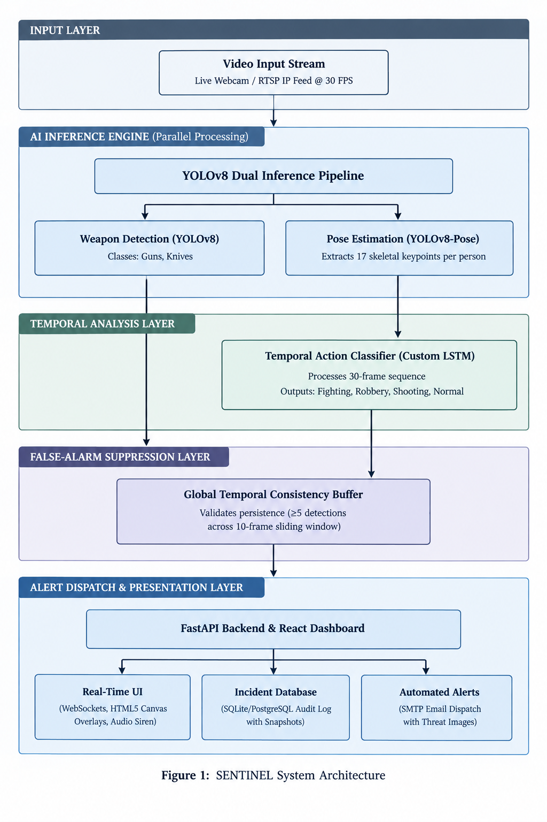

Individual Tasks (mandatory if group project)
Please mention individual tasks in the table indicating individual tasks and justify the one-year effort of two or three students. The expected individual task list with the tentative plan is given below.
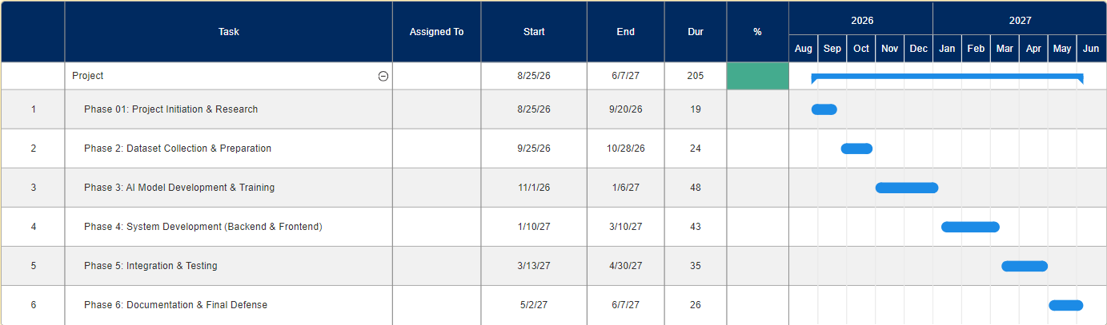
Team Member | Activity | Tentative Date
<Name 1> | Activity 01 | <Date>
 | Activity 02
 | Activity 03
 | Activity 04
 | <Activity n>

Gantt Chart (Mandatory)
As per individual tasks mentioned in the previous section, the Gantt chart shall graphically represent which tasks would be done in which duration, i.e., starting date, end date. What tasks shall be done in parallel, and what tasks shall be done in series? Duration of individual task. (View few samples from the internet before making your own to get ideas)

Tools and Technologies
Category | Tool/Technology | Purpose
Programming Language | Python | AI models, backend API, data processing
Programming Language | JavaScript (JSX) | Frontend dashboard UI
Deep Learning Framework | PyTorch | Model training, inference, GPU acceleration
Object Detection | Ultralytics YOLOv8 | Weapon detection & human pose estimation
Sequence Modeling | Custom LSTM (PyTorch) | Temporal action classification
Computer Vision | OpenCV | Video capture, frame preprocessing, image I/O
Backend Framework | FastAPI | Async REST API, WebSocket server
Frontend Framework | React + Vite | Single-page surveillance dashboard
Canvas Rendering | HTML5 Canvas API | Real-time bounding box overlay
Database | SQLite / PostgreSQL | Incident audit log storage
Email Integration | Python smtplib / Gmail SMTP | Automated email alerts with image attachment
Version Control | Git + GitHub | Source code management & collaboration
IDE | VS Code | Development environment
Annotation Tool | Roboflow / LabelImg | Dataset labeling in YOLO format

Expected Deliverables
Trained YOLOv8 Weapon Detection Model: Fine-tuned weights (.pt) for 2-class weapon localization (Gun, Knife) with documented training metrics.
Trained LSTM Action Classifier Model: Lightweight temporal classifier (.pt) for 4-class (Fighting, Robbery, Shooting, Normal) crime behavior recognition with documented evaluation metrics.
SENTINEL Backend Application: Complete Python FastAPI server with video ingestion, real-time AI inference pipeline, temporal buffer, WebSocket streaming, REST API, and email dispatch.
SENTINEL Dashboard: React-based single-page web application with live video monitoring, canvas bounding-box overlays, alert notifications, and incident history browser.
Incident Database: Structured audit trail of all detected events with timestamps, classification, confidence scores, and snapshot images.
Evaluation Report: Quantitative performance analysis (Precision, Recall, F1, FPS) on benchmark datasets and live demonstration.
FYP Thesis/Report: Complete academic documentation of the research, methodology, implementation, results, and conclusions.
Live Demonstration: Working end-to-end system demo using webcam feed showing real-time threat detection and alert dispatch.

References (if needed)
You must provide references (IEEE style) when appropriate to justify your study.
Use IEEE referencing style available in Microsoft word as shown in Fig. 1.

Figure 1. Word references tab.

General Guidelines
Before starting write up, first, confirm that the correct template has the correct paper size. This FYP proposal template has been tailored for output on the A4 paper size. Specify paper width according to dimensions shown in Figure 2.
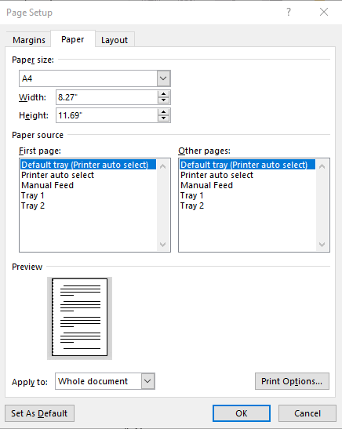
Figure 2. Paper size settings.
Ensure page margins are according to the margin values shown in Fig. 2.

Figure 3. Template page margins.

Template Heading (Heading-1)
Each section should start with heading font size 16, bold, and font face “Times New Roman”. First, outline the proposal in different sections and try to include relevant heading. If it is required to split the section into sub-headings, should use a font size of 13, bold, and font face “Times New Roman.

Selecting a Sub Heading (Heading-2)
Describe FYP in detail problem background, problem complexity, and proposed solution.

Selecting Sub Sub Heading (Heading-3)
Follow the numbering style for the sub-sub-section under the main section. In order to write the third level of subheading, use font size 12 and font face italic “Times New Roman.”

Body Text
All the body text should be in font size 12 and single line spacing. Moreover, ensure that the complete document must use only font-face “Times New Roman”.

Figures and Tables
Use the following instructions to create tables and figures. All the figures and tables must be cross-referred in the text. For example, the figure is inserted in the introduction section in this document figure and can refer to the paper size, and margins see Fig. 1. In the same way, all tables should be cross-referred in the text.

Figures and Tables
Figure captions should be below the figures; table heads should appear above the tables. Insert figures and tables after they are cited in the text. Use the abbreviation “Fig. 1”, even at the beginning of a sentence.
- Table Type Styles
Table Head | Table Column Head
Table Head | Table column subhead | Subhead | Subhead
copy | More table copy
- Example of a figure caption. (figure caption)
Figure Labels: Use 11 point Times New Roman for Figure labels. Use words rather than symbols or abbreviations when writing Figure axis labels to avoid confusing the reader.

